Stacey Napier Project Evidence

P10 - Pseudocode

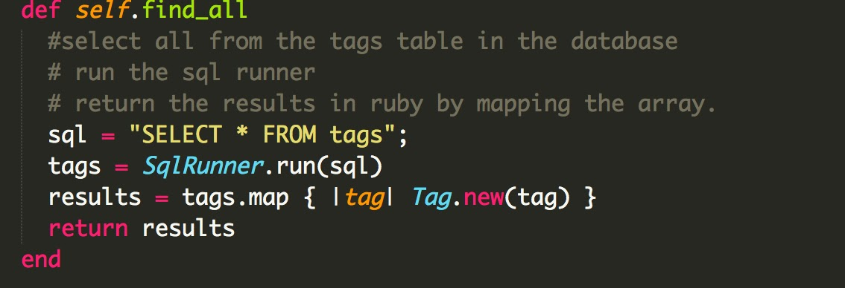

P13

User inputs a new budget which alters the available balance left.

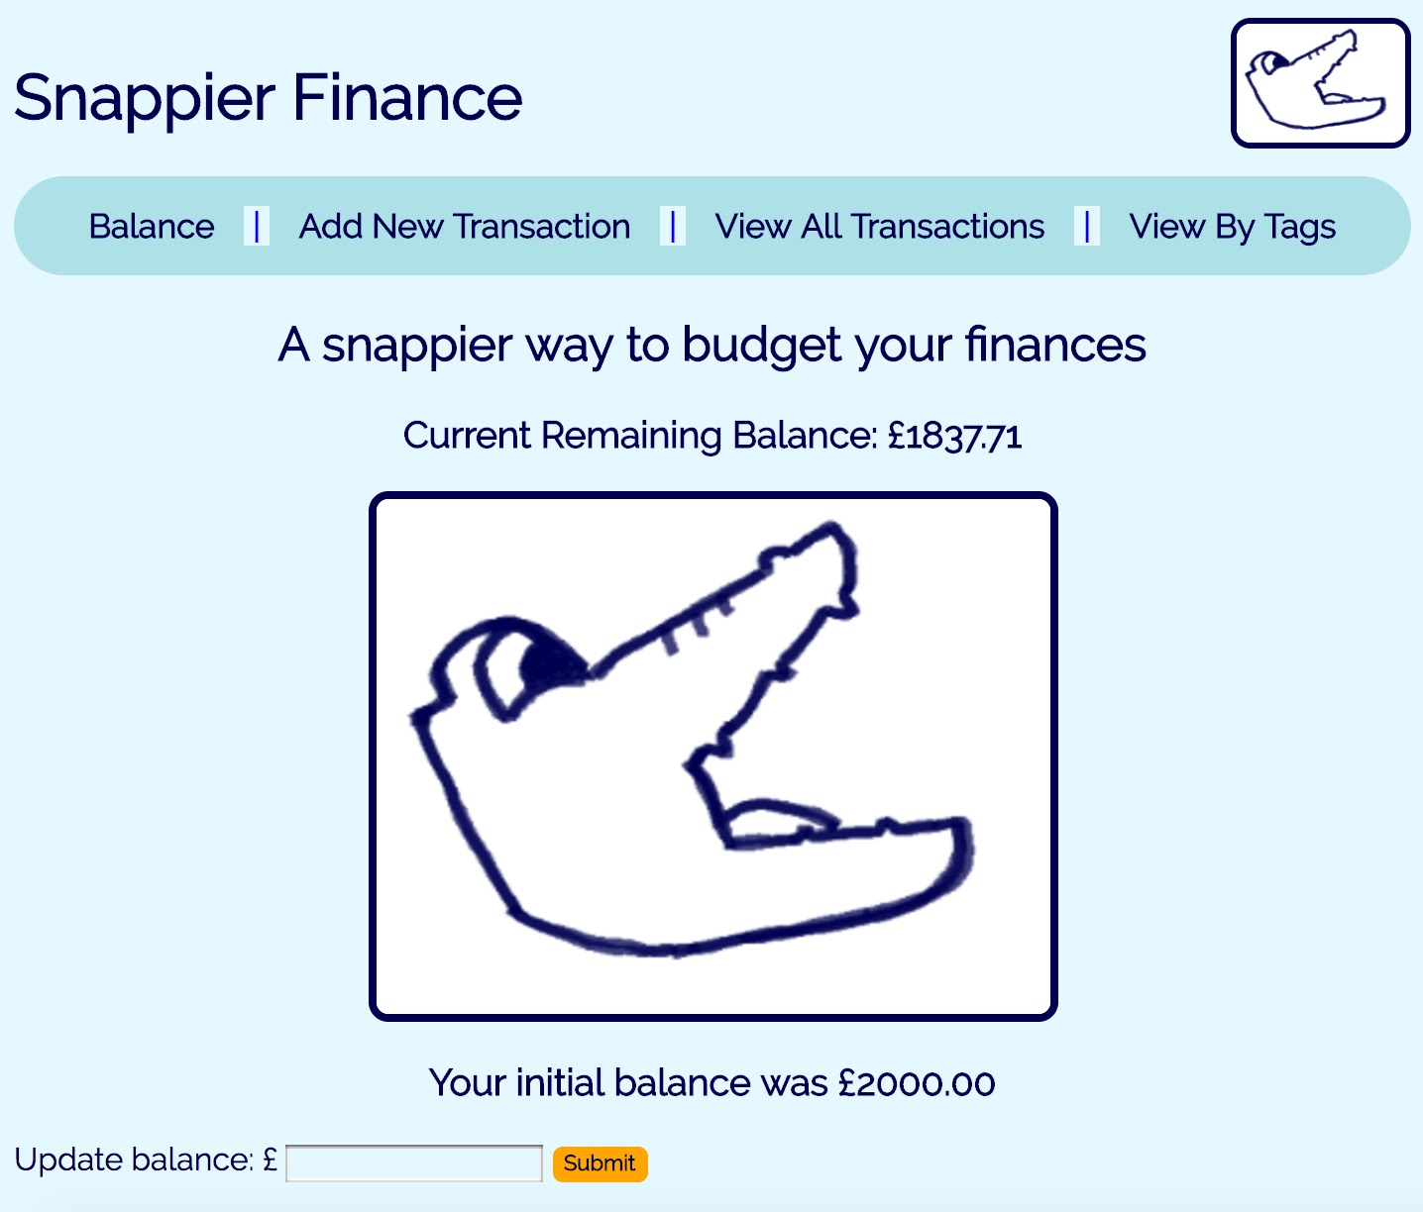

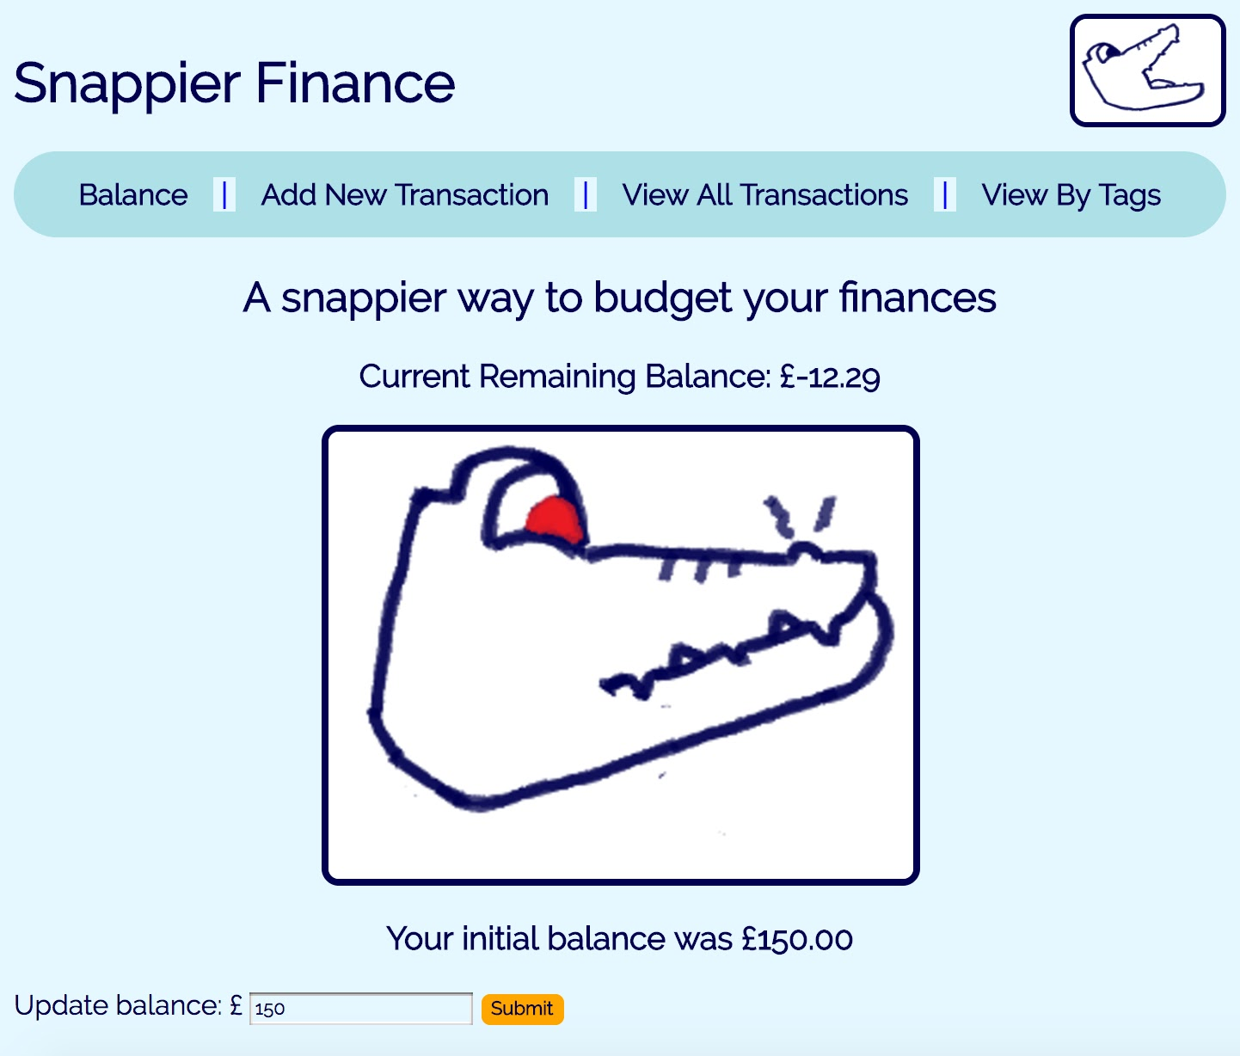

P14

User inputs new transaction details. Showing all transactions confirms transaction saved in the database.

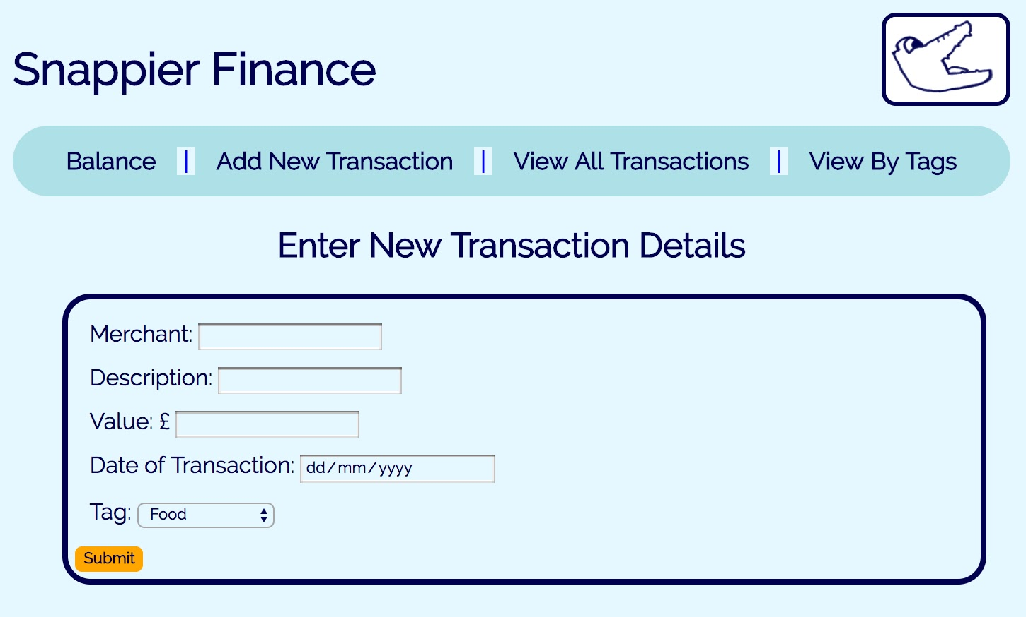

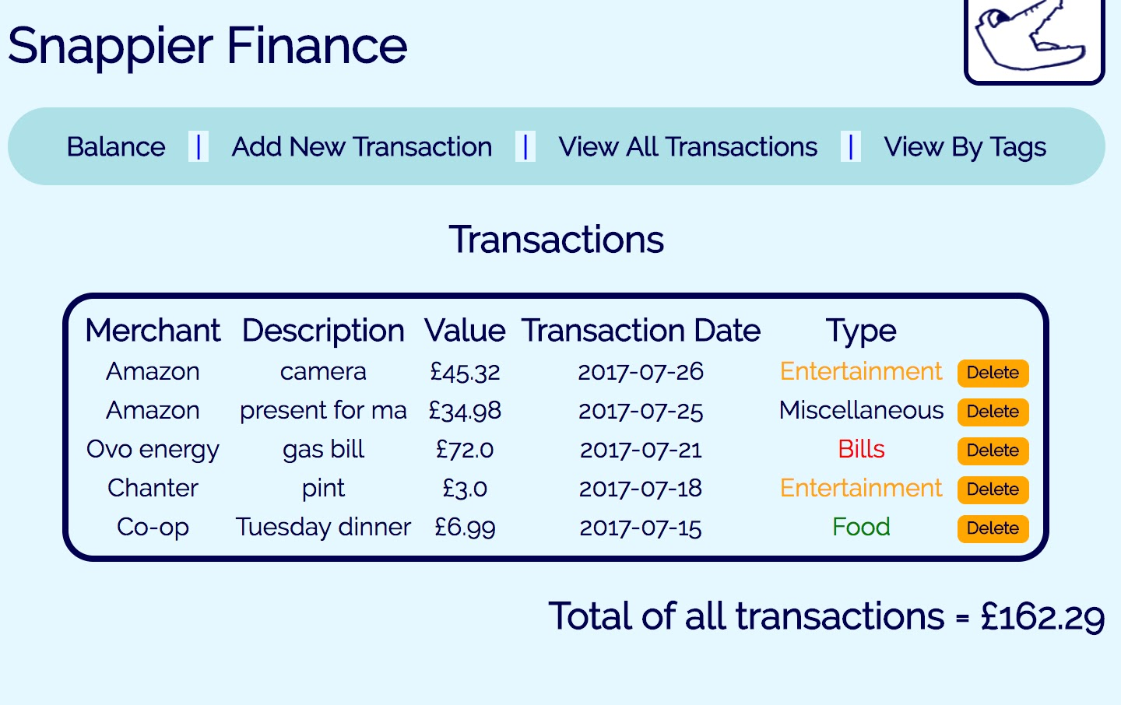

P 15

User selects a tag and is taken to a new page with a list of all the transactions with that tag.

